|  |  |  |  |  |  |  |
| --- | --- | --- | --- | --- | --- | --- |
| |  |  |  |  | | --- | --- | --- | --- | | **logo ngan.png** | | **MINISTRY OF EDUCATION AND TRAINING** | | | **FPT UNIVERSITY** | | |
| Capstone Project Document |
| Maid Services |
| |  |  |  |  |  |  |  |  |  |  |  | | --- | --- | --- | --- | --- | --- | --- | --- | --- | --- | --- | | |  |  | | --- | --- | | **Group 06 – Report 1** | | | **Group member** | Bùi Tiến Tuân - Team Leader - SE60824  Mạnh Quang Tuyến - Team Member - SE60890  Trương Hải Đăng - Team Member - SE60841  Nguyễn Tấn Công - Team Member - SE60920 | | **Supervisor** | Mr. Nguyễn Trọng Tài | | **Ext. Supervisor** | N/A | | **Capstone Project code** | MS | | |

-Ho Chi Minh City, 09/2014-

# Table of Contents

Table of Contents 2

2.1 User Requirement Specification 3

2.1.1 Guest requirement 3

2.1.2 Staff requirement 3

2.1.3 Customer requirement 3

2.1.4 Maid mediator requirement 3

2.1.5 Maid requirement 4

2.1.6 Webmaster requirement 4

2.1.7 System requirement 4

2.2 System Requirement Specification 4

2.2.1 External Interface Requirements 4

2.2.1.1 User Interfaces 4

2.2.1.2 Hardware Interfaces 4

2.2.1.3 Software Interfaces 4

2.2.1.4 Communications Protocol 4

2.2.2 System Features 4

2.2.2.1 List of use case 4

2.2.2.2 Use Case model: 6

2.2.2.3 Use-case diagram 7

2.2.3 Software System Attributes 73

2.2.3.1 Reliability 73

2.2.3.2 Availability 73

2.2.3.3 Security 74

2.2.3.4 Maintainability 74

2.2.3.5 Portability 74

2.2.3.6 Performance 74

2.3 Entity Relationship Diagram or Data Structures 75

2.4 Other material (if any) 75



## User Requirement Specification

|  |  |
| --- | --- |
| Actor | Description |
| **Guest** | A person not login. They have some simple function search. |
| **Staff** | A person help staff and customer connect together and post job request for Maid |
| **Customer** | Hiring maids. They can search, comment rating for job request posted by Maid or Maid Mediator. |
| **Maid Mediator** | They help maid post job request. |
| **Maid** | They can post job request. |
| **Webmaster** | They manager website. |
| **System** | Implement suggestions. |

### Guest requirement

To satisfy the demand of guest, system has these functions:

* **Register account:** guest need to register to become member.
* **Login**: when guest have account they can login with username and password.
* **Search:** guest can search information about jobrequest and recruitment, before they determine become a member.

### Staff requirement

A person: to manage the maid’s request, recruitment and allow maid to post request, view and edit own profile.

* **Manage JobRequest and Recruitment**: staff manage jobrequest and recruitment.
* **View Profile**: staff can view own profile.
* **View Statistic:** staff can view their own statistic, requests statistic and income statistic.

### Customer requirement

A person:

* **Search maids**:
* **Rating**:
* **Comment**:
* **Manage recruitment**:
* **View customer statistic**:

### Maid mediator requirement

A person:

* **Apply job**:
* **Search jobs**:
* **Manage job request**:
* **View maid statistic**:

### Authenticated user requirement

A person: who login to the web site (customer, maid mediator, staff, webmaster)

* **Search:** guest can search information about jobrequest and recruitment.
* **View maid:** staff and maid mediator can view their own maid profile.
* **View profile:** authenticated user can view their own profile.
* **Log out:** authenticated user can log out the website.
* **View JobRequest:** authenticated user can view jobrequest.
* **View Recruitment:** authenticated user can view recruitment.
* **View Notification:** authenticated user can view notification.
* **View Statistic:** authenticated user can view own statistic.

### Webmaster requirement

A person:

* **Manager user**:

### System requirement

A person:

* **Suggests**:
* **Handle unconfirmed request**:
* **Notify**:

## System Requirement Specification

### External Interface Requirements

#### User Interfaces

* The general interface of website is simple and simplifies user interfaces.
* The design is simple and monochrome is more prefer.
* The layout of information in page is showing simple but full of functions.
* The error, warning and notification messages must be simple, neat, and easy to understand. Error warning does not discomfort to the user.
* The working layout of user is spacious.
* Member can contact with manager and admin easily.

#### Hardware Interfaces

There is no extra hardware interfaces are needed. The system will use the standard hardware and data communications resources of a standard computer.

#### Software Interfaces

Browsers: Firefox, Chrome

#### Communications Protocol

BSF website uses HTTP/HTTPS protocol for communication with the web browser and the web server. In addition, TCP/IP network protocol for communication with HTTP protocol

### System Features

#### List of use case

|  |  |  |  |  |  |  |  |  |
| --- | --- | --- | --- | --- | --- | --- | --- | --- |
| No. | Use case name | Use case ID | Guest | Staff | Customer | Maid mediator | Webmaster | System |
| 1 | Register Account | 001 | x |  |  |  |  |  |
| 2 | Login | 002 | x |  |  |  |  |  |
| 3 | Search | 003 | x | x | x | x | x |  |
| 4 | Search by Age | 004 | x | x | x | x | x |  |
| 5 | Search by Skill | 005 | x | x | x | x | x |  |
| 6 | Search by Gender | 006 | x | x | x | x | x |  |
| 7 | Search by Salary | 007 | x | x | x | x | x |  |
| 8 | Search by Time | 008 | x | x | x | x | x |  |
| 9 | View JobRequest | 009 | x | x | x | x | x |  |
| 10 | View Recruitment | 010 | x | x | x | x | x |  |
| 11 | View Profile | 011 | x | x | x | x | x |  |
| 12 | Log out | 012 | x | x | x | x | x |  |
| 13 | View Notifications | 013 |  | x | x | x | x |  |
| 14 | Add Staff | 014 |  |  |  |  | x |  |
| 15 | Manage User | 015 |  |  |  |  | x |  |
| 16 | Ban Account | 016 |  |  |  |  | x |  |
| 17 | Unban Account | 017 |  |  |  |  | x |  |
| 18 | View Requests Statistic | 018 |  | x |  |  | x |  |
| 19 | View Income Statistic | 019 |  | x |  |  | x |  |
| 20 | Manage Config | 020 |  |  |  |  | x |  |
| 21 | Suggest | 021 |  |  |  |  |  | x |
| 22 | Send SMS | 022 |  |  |  |  |  | x |
| 23 | Send Notifications | 023 |  |  |  |  |  | x |
| 24 | Apply JobRequest | 024 |  |  | x |  |  |  |
| 25 | Comment JobRequest | 025 |  |  | x |  |  |  |
| 26 | Rate JobRequest | 026 |  |  | x |  |  |  |
| 27 | Edit Customer Profile | 027 |  |  | x |  |  |  |
| 28 | Extend Recruitment | 028 |  |  | x |  |  |  |
| 29 | Hide Recruitment | 029 |  |  | x |  |  |  |
| 30 | Public Recruitment | 030 |  |  | x |  |  |  |
| 31 | Post Recruitment | 031 |  |  | x |  |  |  |
| 32 | Edit Recruitment | 032 |  |  | x |  |  |  |
| 33 | Pay | 033 |  |  | x |  |  |  |
| 34 | View Customer Statistic | 034 |  |  | x |  |  |  |
| 35 | Add Maid | 035 |  | x |  | x |  |  |
| 36 | View Maid | 036 |  | x |  | x |  |  |
| 37 | Edit Maid | 037 |  | x |  | x |  |  |
| 38 | Public JobRequest | 038 |  | x |  | x |  |  |
| 39 | Hide JobRequest | 039 |  | x |  | x |  |  |
| 40 | Extend JobRequest | 040 |  | x |  | x |  |  |
| 41 | Edit JobRequest | 041 |  | x |  | x |  |  |
| 42 | Edit Maid Mediator Profile | 042 |  |  |  | x |  |  |
| 43 | Post JobRequest | 043 |  | x |  | x |  |  |
| 44 | Active Recruitment | 044 |  | x |  |  |  |  |
| 45 | Approved JobRequest | 045 |  | x |  |  |  |  |
| 46 | View Request Statistic | 046 |  | x |  |  | x |  |
| 47 | View Income Statistic | 047 |  | x |  |  | x |  |
| 48 | View Maid Manager Statistic | 048 |  | x |  | x |  |  |
| 49 | Edit Maid Manager Profile | 049 |  | x |  | x |  |  |
| 50 | Manage Number of Kmean | 050 |  |  |  |  | x |  |
| 51 | Manage Number of Weeks | 051 |  |  |  |  | x |  |
| 52 | Manage JobRequest Price | 052 |  |  |  |  | x |  |
| 53 | Manage Recruitment Price | 053 |  |  |  |  | x |  |
| 54 | Manage JobRequest | 054 |  | x |  |  |  |  |
| 55 | Manage Recruitment | 055 |  | x |  |  |  |  |
| 56 | Manage Applied JobRequest | 056 |  | x |  |  |  |  |
| 57 | Active JobRequest | 057 |  | x |  |  |  |  |
| 58 | Active Recruitment | 058 |  | x |  |  |  |  |
| 59 | Approve JobRequest | 059 |  | x |  |  |  |  |

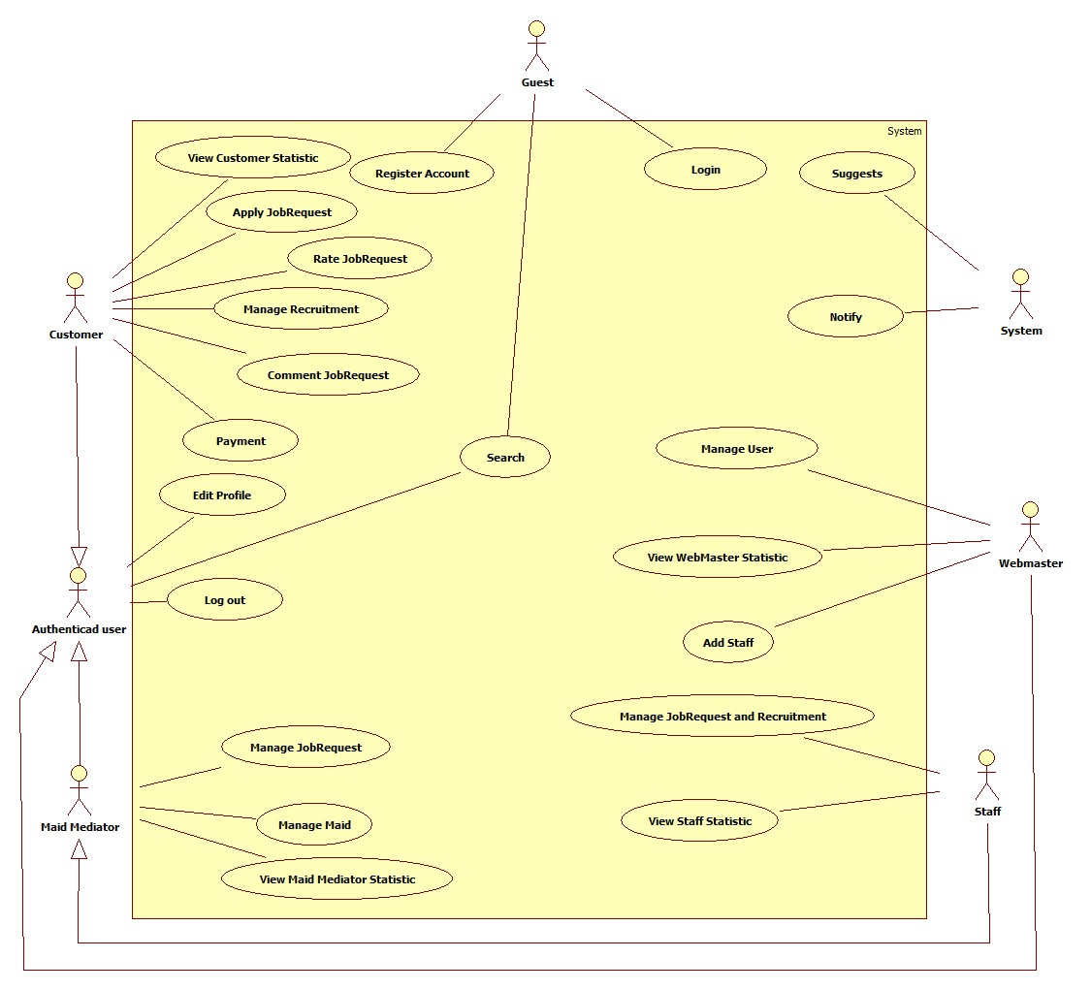

#### Use Case model:

#### Use-case diagram

##### <Guest> Register

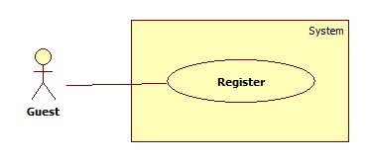

|  |  |  |  |  |
| --- | --- | --- | --- | --- |
| **USE CASE SPECIFICATION** | | | | |
| **Use-case No.** | UC001 | **Use-case Version** | | 1.0 |
| **Use-case Name** | Register | | | |
| **Author** | CongNT | | | |
| **Date** | 21/09/2014 | **Priority** | High | |
| **Actor:** Guest  **Summary:** This use case allows guest to create an account in website system.  **Goal:**  It helps guest to create an account on website.  **Trigger:** Click on the “Đăng ký” button to register on home page  **Pre-conditions:**   * Page is loaded successfully * Register page will be shown   **Post conditions:**   * Success: Register successfully, guest will have an account in system and will be logged into system. * Failure: Show message error.   **Main Success Scenario:**   |  |  | | --- | --- | | Actor Action | System Response | | 1. Click on “Đăng ký” button home page 2. Input right information about username, email, password, full name, phone, role 3. Click on the “Đăng ký” button [Alternative 1] | 2. System redirect to register page for guest, contain a register form :   * Tên tài khoản [Username: textbox ] * Mật khẩu [Password : textbox] * Nhập lại mật khẩu [Repassword : textbox] * Địa chỉ email [Email: textbox]   In format: /^([a-zA-Z0-9_\.\-])+\@(([a-zA-Z0-9\-])+\.)+([a-zA-Z0-9]{2,4})+$/ .   * Họ và tên [Fullname : textbox] * Điện thoại[Phone : textbox] * Vai trò[Role : dropdownlist] * Đăng ký[button]  1. Validate valid username, password, email, phone 2. Redirect to login page |   **Alternative Scenario:**   |  |  | | --- | --- | | Actor Action | System Response | | 1. [Alternative 1] Click on the “MaidService” icon. | 1. Back to home page |   **Exceptions:**   |  |  | | --- | --- | | Actor Action | System Response | | 1. “Tên đăng nhập” is emtpy 2. “”Mật khẩu” is empty 3. “Nhập lại mật khẩu” if different with “Mật khẩu” 4. “Điện thoại” is empty or not a numberic value 5. “Họ và tên” is empty 6. “Email” is empty or not correct type [abc@abc.abc](mailto:abc@abc.abc) 7. “Tên đăng nhập” is already have in database | 1. Display message: “Vui lòng nhập tên đăng nhập” 2. Display message: “Vui lòng nhập mật khẩu” 3. Display message: “Mật khẩu không trùng khớp” 4. Display message: “Vui lòng nhập số” 5. Display message: “Vui lòng nhập họ và tên” 6. Display message: “Vui lòng nhập đúng định dạng [abc@abc.abc](mailto:abc@abc.abc)” 7. Display message: “Tên đăng nhập đã tồn tại” |   **Relationships:** N/A  **Business Rules:** When register an account, username have to input username, email, password, phone.   * If username is already have in database or empty, an error message will be displayed. * If password is empty, an error message will be displayed. * If confirm password is not the same as password, an error message will be displayed. * If phone is empty or not a numberic value, an error message will be displayed. | | | | |

##### <System> Suggest

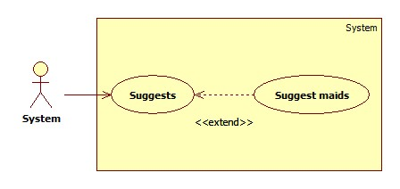

|  |  |  |  |  |
| --- | --- | --- | --- | --- |
| **USE CASE SPECIFICATION** | | | | |
| **Use-case No.** | UC019 | **Use-case Version** | | 1.0 |
| **Use-case Name** | Suggest maids | | | |
| **Author** | TuanBT | | | |
| **Date** | 24/09/2014 | **Priority** | High | |
| **Actor:** System  **Summary:** system automatically suggest maids for customer when they post a recruitment on MS-Website.  **Goal:**  The use case will help MS-Website suggest maids for customer when they post a recruitment.  **Trigger:**   * Click [Yêu cầu công việc] button. * Fill all data. * Click [Đăng yêu cầu] button.   **Pre-conditions:**   * Post an invalid recruitment.   **Post conditions:**   * Success: List maid will appear by suggestion criteria. * Failure: List maid upcoming will appear by create date order.   **Main Success Scenario:**   |  |  | | --- | --- | | Actor Action | System Response | | 1. User click on the [Đăng yêu cầu] button.   [Alternative 1] | 1. Show list jobs request by suggest criteria.   [Exception 1] |   **Alternative Scenario:**   |  |  | | --- | --- | | Actor Action | System Response | | 1. User click on the [Đăng yêu cầu] button. | 1. Show list jobs request by suggest criteria. |   **Exceptions:**   |  |  | | --- | --- | | Actor Ation | System Response | | 1. System fail to load data | 1. Show list jobs request |   **Relationships:** N/A  **Business Rules:**  When customer post a recruitment, system calculate jobs request this nearer than recruitment. | | | | |

##### <System> Notify

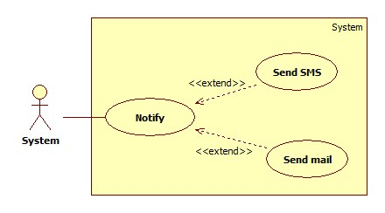

|  |  |  |  |  |
| --- | --- | --- | --- | --- |
| **USE CASE SPECIFICATION** | | | | |
| **Use-case No.** | UC020 | **Use-case Version** | | 1.0 |
| **Use-case Name** | Notify | | | |
| **Author** |  | | | |
| **Date** | 24/09/2014 | **Priority** | Normal | |
| **Actor:** System  **Summary:** Notify for Maid and Customer when they apply together.  **Goal:**  Send mail and SMS to Maid and Customer when apply. System know when accept a job.  **Trigger:** Both Customer and Maid post an invalid recruitment and job request. They apply together.  **Pre-conditions:**   * Apply success.   **Post conditions:**   * Success: Send email and SMS * Failure: An error message on screen   **Main Success Scenario:**   |  |  | | --- | --- | | Actor Action | System Response | | 1. System receive Customer and Maid apply | 2 Send email and SMS  [Exception 1] |   **Alternative Scenario:**   |  |  | | --- | --- | | Actor Action | System Response | | N/A | N/A |   **Exceptions:**   |  |  | | --- | --- | | Actor Action | System Response | | 1. Email or phone number is blank | 1. Show error “Không thể gửi email hoặc tin nhắn” |   **Relationships:** N/A  **Business Rules:** System must send email or SMS, help maid or customer know when request of them apply. | | | | |

##### <Guest> Login

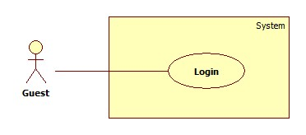

|  |  |  |  |  |
| --- | --- | --- | --- | --- |
| **USE CASE SPECIFICATION** | | | | |
| **Use-case No.** | UC002 | **Use-case Version** | | 1.0 |
| **Use-case Name** | Login | | | |
| **Author** | CongNT | | | |
| **Date** | 21/09/2014 | **Priority** | High | |
| **Actor:** Guest  **Summary:** This use case allow guest to login the website  **Goal:** Guest become a member of the website  **Trigger:** Click on the “Đăng nhập” button to login on home page  **Pre-conditions:**   * Page is loaded successfully * The login page will shown   **Post conditions:**   * Success: Login successfully, guest will have a role in system and can use more function of system. * Failure: Show message error   **Main Success Scenario:**   |  |  | | --- | --- | | Actor Action | System Response | | 1. Click on “Đăng nhập” button home page 2. Input right information about username, password 3. Click on the “Đăng nhập” button | 1. System redirect to login page for guest, contain a login form :  * Tên tài khoản [Username: textbox ] * Mật khẩu [Password : textbox] * Đăng nhập [button]  1. Redirect to login successful page |   **Alternative Scenario:**   |  |  | | --- | --- | | Actor Action | System Response | | 1. [Alternative 1] Click on the “Đóng” button. | 1. Back to home page |   **Exceptions:**   |  |  | | --- | --- | | Actor Action | System Response | | 1. “Tên đăng nhập”,”Mật khẩu” ,” is empty 2. “Tên đăng nhập”,”Mật khẩu” ,” is incorrect 3. “Tên đăng nhập” is IsActive(false) | 1. Display message “Vui lòng nhập tên đăng nhập” or “Vui lòng nhập mật khẩu” 2. Display message “Tên đăng nhập hoặc mật khẩu không đúng, vui lòng thử lại” 3. Display message “Tên đăng nhập đã bị khóa” |   **Relationships:** N/A  **Business Rules:** User must input username, password. The username and password must unique and have in database and the username is not blocked. If the username is blocked or not unique or not have in database, an error message is displayed. | | | | |

##### <Authenticated user > Search

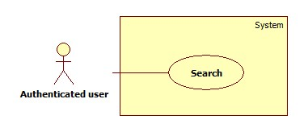

|  |  |  |  |  |
| --- | --- | --- | --- | --- |
| **USE CASE SPECIFICATION** | | | | |
| **Use-case No.** | UC003 | **Use-case Version** | | 1.0 |
| **Use-case Name** | Search | | | |
| **Author** | CongNT | | | |
| **Date** | 21/09/2014 | **Priority** | High | |
| **Actor:** Guest, Customer, Maid Mediator, Staff, Webmaster.  **Summary:** This use case allow guest can search information by job  **Goal:** Guest can search information by search job  **Trigger:** Fill in “Tìm kiếm” textbox, then click on “Tìm kiếm” button  **Pre-conditions:**   * Page is loaded successfully * The search page will shown   **Post conditions:**   * Success: Search successfully, the system will shown search result * Failure:   **Main Success Scenario:**   |  |  | | --- | --- | | Actor Action | System Response | | 1. Fill in “Tìm kiếm” text box 2. Click on “Tìm kiếm” button | 1. System redirect to search page for guest and show search results |   **Alternative Scenario:**   |  |  | | --- | --- | | Actor Action | System Response | | 1. [Alternative 1] Click on the “MaidService” icon | 1. Back to home page |   **Exceptions:**   |  |  | | --- | --- | | Actor Action | System Response | |  |  |   **Relationships:** N/A  **Business Rules:** All of role can search but search results are different in some roles:   * If user is a guest, search results are jobrequests and recruitments. * If user is a staff, customer or webmaster, search results are jobrequests and recruitments. * If user is a maid mediator, search results are jobrequests. | | | | |

##### < Authenticated user >Advance Search

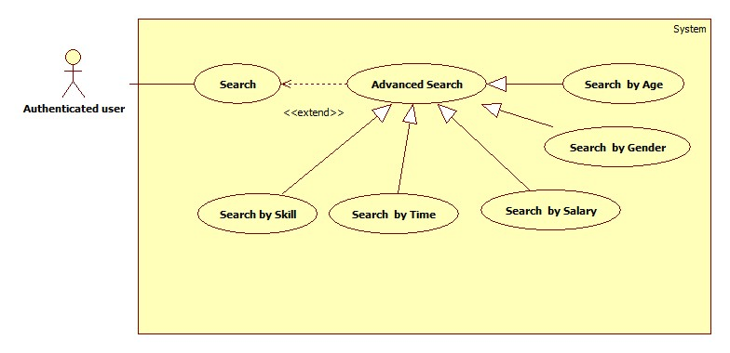

###### **<Authenticated user> Search by Skill**

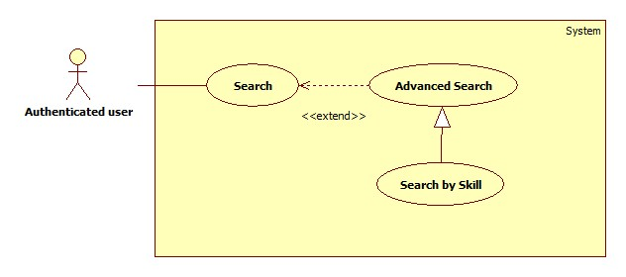

|  |  |  |  |  |
| --- | --- | --- | --- | --- |
| **USE CASE SPECIFICATION** | | | | |
| **Use-case No.** | UC004 | **Use-case Version** | | 1.0 |
| **Use-case Name** | Search by skill | | | |
| **Author** | CongNT | | | |
| **Date** | 21/09/2014 | **Priority** | High | |
| **Actor:** Guest, Customer, Maid Mediator, Staff, Webmaster.  **Summary:** This use case allow guest can search information by skill  **Goal:** Guest can search information by search skill  **Trigger:** Click on skill radio button on website  **Pre-conditions:**   * Page is loaded successfully * The search page will shown   **Post conditions:**   * Success: Search successfully, the system will shown search result * Failure:   **Main Success Scenario:**   |  |  | | --- | --- | | Actor Action | System Response | | 1. Fill in “Tìm kiếm” text box 2. Click on “Tìm kiếm” button 3. Click on skill radio button | 1. System redirect to search page 2. Show the result suitable for each button |   **Alternative Scenario:**   |  |  | | --- | --- | | Actor Action | System Response | | 1. [Alternative 1] Click on the “Đóng” button. | 1. Back to home page |   **Exceptions:**   |  |  | | --- | --- | | Actor Action | System Response | |  |  |   **Relationships:** N/A  **Business Rules:** All of role can search but search results are different in some roles:   * If user is a guest, search results are jobrequests and recruitments. * If user is a staff or webmaster, search results are jobrequests and recruitments. * If user is a maid mediator, search results are recruitment. * If user is a customer, search results are jobrequests. | | | | |

###### **<Authenticated user> Search by Age**

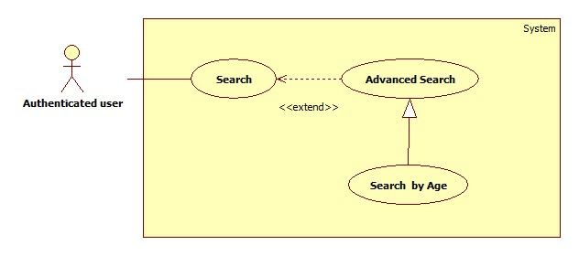

|  |  |  |  |  |
| --- | --- | --- | --- | --- |
| **USE CASE SPECIFICATION** | | | | |
| **Use-case No.** | UC005 | **Use-case Version** | | 1.0 |
| **Use-case Name** | Search by age | | | |
| **Author** | CongNT | | | |
| **Date** | 21/09/2014 | **Priority** | High | |
| **Actor:** Guest, Customer, Maid Mediator, Staff, Webmaster.  **Summary:** This use case allow guest can search information by age  **Goal:** Guest can search information by search age  **Trigger:** Click on age radio button on website  **Pre-conditions:**   * Page is loaded successfully * The search page will shown   **Post conditions:**   * Success: Search successfully, the system will shown search result * Failure:   **Main Success Scenario:**   |  |  | | --- | --- | | Actor Action | System Response | | 1. Fill in “Tìm kiếm” text box 2. Click on “Tìm kiếm” button 3. Click on “25-30” or “30-35” or “35-40” link | 1. System redirect to search page for guest 2. Show the result suitable for each link |   **Alternative Scenario:**   |  |  | | --- | --- | | Actor Action | System Response | | 1. [Alternative 1] Click on the “Đóng” button. | 1. Back to home page |   **Exceptions:**   |  |  | | --- | --- | | Actor Action | System Response | |  |  |   **Relationships:** N/A  **Business Rules:** All of role can search but search results are different in some roles:   * If user is a guest, search results are jobrequests and recruitments. * If user is a staff, customer or webmaster, search results are jobrequests and recruitments. * If user is a maid mediator, search results are jobrequests. | | | | |

###### **<Authenticated user> Search by Salary**

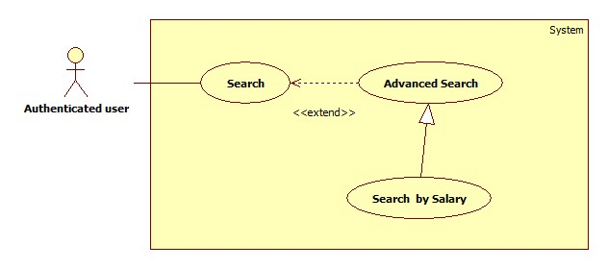

|  |  |  |  |  |
| --- | --- | --- | --- | --- |
| **USE CASE SPECIFICATION** | | | | |
| **Use-case No.** | UC006 | **Use-case Version** | | 1.0 |
| **Use-case Name** | Search by salary | | | |
| **Author** | CongNT | | | |
| **Date** | 21/09/2014 | **Priority** | High | |
| **Actor:** Guest, Customer, Maid Mediator, Staff, Webmaster.  **Summary:** This use case allow guest can search information by salary  **Goal:** Guest can search information by search salary  **Trigger:** Click on salary radio button on website  **Pre-conditions:**   * Page is loaded successfully * The search page will shown   **Post conditions:**   * Success: Search successfully, the system will shown search result * Failure:   **Main Success Scenario:**   |  |  | | --- | --- | | Actor Action | System Response | | 1. Fill in “Tìm kiếm” text box 2. Click on “Tìm kiếm” button 3. Click on “Dưới 3 triệu” or “3-5 triệu” or “trên 5 triệu” link | 1. System redirect to search page for guest 2. Show the result suitable for each link |   **Alternative Scenario:**   |  |  | | --- | --- | | Actor Action | System Response | | 1. [Alternative 1] Click on the “Đóng” button. | 1. Back to home page |   **Exceptions:**   |  |  | | --- | --- | | Actor Action | System Response | |  |  |   **Relationships:** N/A  **Business Rules:** All of role can search but search results are different in some roles:   * If user is a guest, search results are jobrequests and recruitments. * If user is a staff, customer or webmaster, search results are jobrequests and recruitments. * If user is a maid mediator, search results are jobrequests. | | | | |

###### **<Authenticated user> Search by Time**

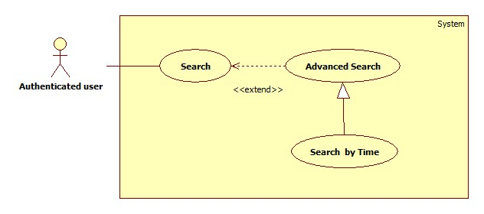

|  |  |  |  |  |
| --- | --- | --- | --- | --- |
| **USE CASE SPECIFICATION** | | | | |
| **Use-case No.** | UC007 | **Use-case Version** | | 1.0 |
| **Use-case Name** | Search by time | | | |
| **Author** | CongNT | | | |
| **Date** | 21/09/2014 | **Priority** | High | |
| **Actor:** Guest, Customer, Maid Mediator, Staff, Webmaster.  **Summary:** This use case allow guest can search information by time  **Goal:** Guest can search information by search time  **Trigger:** Click on time radio button on website  **Pre-conditions:**   * Page is loaded successfully * The search page will shown   **Post conditions:**   * Success: Search successfully, the system will shown search result * Failure:   **Main Success Scenario:**   |  |  | | --- | --- | | Actor Action | System Response | | 1. Fill in “Tìm kiếm” text box 2. Click on “Tìm kiếm” button 3. Click on “Cách đây 1 ngày” or “Cách đây 3 ngày” or “Cách đây 5 ngày” or “Cách đây 7 ngày” or “Cách đây 14 ngày” or “Cách đây 30 ngày” link | 1. System redirect to search page for guest 2. Show the result suitable for each link |   **Alternative Scenario:**   |  |  | | --- | --- | | Actor Action | System Response | | 1. [Alternative 1] Click on the “Đóng” button. | 1. Back to home page |   **Exceptions:**   |  |  | | --- | --- | | Actor Action | System Response | |  |  |   **Relationships:** N/A  **Business Rules:** All of role can search but search results are different in some roles:   * If user is a guest, search results are jobrequests and recruitments. * If user is a staff, customer or webmaster, search results are jobrequests and recruitments. * If user is a maid mediator, search results are jobrequests. | | | | |

###### **<Authenticated user> Search by Gender**

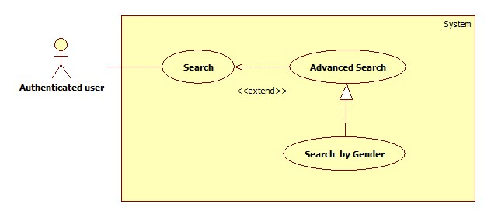

|  |  |  |  |  |
| --- | --- | --- | --- | --- |
| **USE CASE SPECIFICATION** | | | | |
| **Use-case No.** | UC008 | **Use-case Version** | | 1.0 |
| **Use-case Name** | Search by gender | | | |
| **Author** | CongNT | | | |
| **Date** | 21/09/2014 | **Priority** | High | |
| **Actor:** Guest, Customer, Maid Mediator, Staff, Webmaster.  **Summary:** This use case allow guest can search information by gender  **Goal:** Guest can search information by search name  **Trigger:** Click on gender radio button on website  **Pre-conditions:**   * Page is loaded successfully * The search page will shown   **Post conditions:**   * Success: Search successfully, the system will shown search result * Failure:   **Main Success Scenario:**   |  |  | | --- | --- | | Actor Action | System Response | | 1. Fill in “Tìm kiếm” text box 2. Click on “Tìm kiếm” button 3. Click on “Nam” or “Nữ” link | 1. System redirect to search page for guest 2. Show the result suitable for each link |   **Alternative Scenario:**   |  |  | | --- | --- | | Actor Action | System Response | | 1. [Alternative 1] Click on the “Đóng” button. | 1. Back to home page |   **Exceptions:**   |  |  | | --- | --- | | Actor Action | System Response | |  |  |   **Relationships:** N/A  **Business Rules:** All of role can search but search results are different in some roles:   * If user is a guest, search results are jobrequests and recruitments. * If user is a staff, customer or webmaster, search results are jobrequests and recruitments. * If user is a maid mediator, search results are jobrequests. | | | | |

##### <Staff> Manage JobRequest and Recruitment

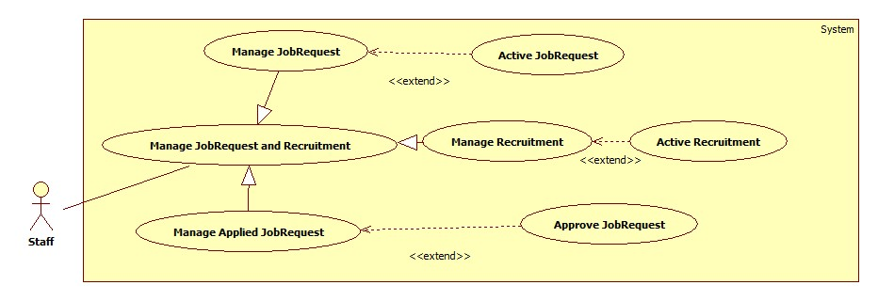

###### **<Staff> Manage JobRequest**

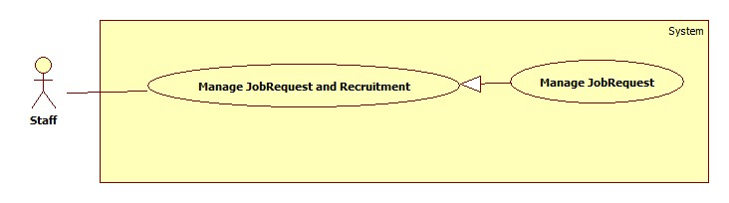

|  |  |  |  |  |
| --- | --- | --- | --- | --- |
| **USE CASE SPECIFICATION** | | | | |
| **Use-case No.** | UC054 | **Use-case Version** | | 1.0 |
| **Use-case Name** | Manage jobrequest | | | |
| **Author** | CongNT | | | |
| **Date** | 21/09/2014 | **Priority** | High | |
| **Actor:** Staff  **Summary:** This use case allow staff view all jobrequests that is not active  **Goal:** Staff can view all jobrequests that is not active  **Trigger:** User click “Quản lý” link  **Pre-conditions:**   * Page is loaded successfully * User login as staff successful   **Post conditions:**   * Success: Login successfully, the job request will be allowed to public on website * Failure:   **Main Success Scenario:**   |  |  | | --- | --- | | Actor Action | System Response | | 1. Login as a staff | 1. System redirect to list of job request |   **Alternative Scenario:**   |  |  | | --- | --- | | Actor Action | System Response | | 1. Click on the “Đăng xuất” button. | 1. Clear session and back to home page |   **Exceptions:**   |  |  | | --- | --- | | Actor Action | System Response | | 1. System fail to load data | 1. Show message “Hệ thống đang bảo trì” |   **Relationships:** N/A  **Business Rules:** User login as a staff. The website load all jobrequests that is not active. Staff choose a jobrequest. When user choose post time for jobrequest to post on website, after that time if jobrequest is not active, it will be remove from database. | | | | |

###### **<Staff> Active JobRequest**

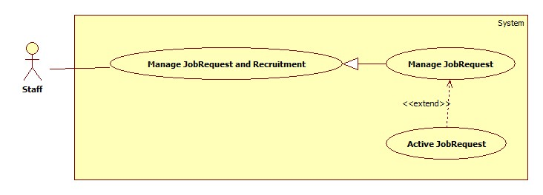

|  |  |  |  |  |
| --- | --- | --- | --- | --- |
| **USE CASE SPECIFICATION** | | | | |
| **Use-case No.** | UC057 | **Use-case Version** | | 1.0 |
| **Use-case Name** | Active JobRequest | | | |
| **Author** | CongNT | | | |
| **Date** | 21/09/2014 | **Priority** | High | |
| **Actor:** Staff  **Summary:** This use case allow staff to active job request to public it on website  **Goal:** Staff can allow job request to public on website  **Trigger:** User choose a job request then click “Chấp nhận” button  **Pre-conditions:**   * Page is loaded successfully * User login as staff successful   **Post conditions:**   * Success: Login successfully, the job request will be allowed to public on website * Failure:   **Main Success Scenario:**   |  |  | | --- | --- | | Actor Action | System Response | | 1. Login as a staff 2. Choose a job request, click “Kích hoạt” button 3. Click “Chấp nhận” button. | 1. System redirect to list of job request 2. System show a “Xác nhận kích hoạt” pop up. 3. Change IsActive(false) to IsActive(true) and save change to database |   **Alternative Scenario:**   |  |  | | --- | --- | | Actor Action | System Response | | 1. Click on the “Đăng xuất” button. | 1. Clear session and back to home page |   **Exceptions:**   |  |  | | --- | --- | | Actor Action | System Response | | 1. System fail to load data | 1. Show message “Hệ thống đang bảo trì” |   **Relationships:** N/A  **Business Rules:** User login as a staff. | | | | |

###### **<Staff> Manage Recruitment**

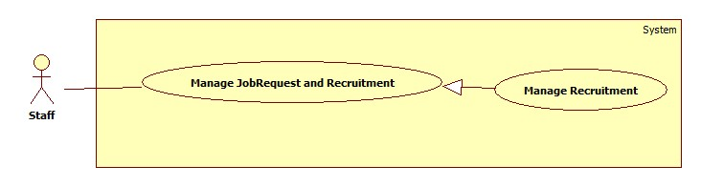

|  |  |  |  |  |
| --- | --- | --- | --- | --- |
| **USE CASE SPECIFICATION** | | | | |
| **Use-case No.** | UC055 | **Use-case Version** | | 1.0 |
| **Use-case Name** | Manage recruitment | | | |
| **Author** | CongNT | | | |
| **Date** | 21/09/2014 | **Priority** | High | |
| **Actor:** Staff  **Summary:** This use case allow staff view all recruitments that is not active  **Goal:** Staff can view all recruitments that is not active  **Trigger:** User click “Quản lý” link, then click “Kích hoạt yêu cầu tìm việc” link  **Pre-conditions:**   * Page is loaded successfully * User login as staff successful   **Post conditions:**   * Success: Login successfully, the recruitments will be allowed to public on website * Failure:   **Main Success Scenario:**   |  |  | | --- | --- | | Actor Action | System Response | | 1. Login as a staff 2. Click “Kích hoạt yêu cầu tìm người” link | 1. System redirect to list of job request 2. System redirect to list of recruitment |   **Alternative Scenario:**   |  |  | | --- | --- | | Actor Action | System Response | | 1. Click on the “Đăng xuất” button. | 1. Clear session and back to home page |   **Exceptions:**   |  |  | | --- | --- | | Actor Action | System Response | | 1. System fail to load data | 1. Show message “Hệ thống đang bảo trì” |   **Relationships:** N/A  **Business Rules:** User login as a staff. The website load all recruitments that is not active. Staff choose a recruitment. When user choose post time for recruitment to post on website, after that time if recruitment is not active, it will be remove from database. | | | | |

###### **<Staff> Active Recruitment**

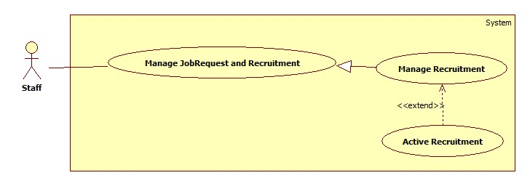

|  |  |  |  |  |
| --- | --- | --- | --- | --- |
| **USE CASE SPECIFICATION** | | | | |
| **Use-case No.** | UC058 | **Use-case Version** | | 1.0 |
| **Use-case Name** | Active Recruitment | | | |
| **Author** | CongNT | | | |
| **Date** | 21/09/2014 | **Priority** | High | |
| **Actor:** Staff  **Summary:** This use case allow staff to active job request to public it on website  **Goal:** Staff can allow job request to public on website  **Trigger:** User choose a recruitment then click “Chấp nhận” button  **Pre-conditions:**   * Page is loaded successfully * User login as staff successful   **Post conditions:**   * Success: Login successfully, the job request will be allowed to public on website * Failure:   **Main Success Scenario:**   |  |  | | --- | --- | | Actor Action | System Response | | 1. Login as a staff 2. Click “Xác nhận hoàn tất công việc” link 3. Choose a recruitment, click “Hoàn tất” button 4. Click “Chấp nhận” button. | 1. System redirect to list of job request 2. System redirect to list of applied job requests 3. System show a “Xác nhận kích hoạt” pop up. 4. Change IsActive(false) to IsActive(true) and save change to database |   **Alternative Scenario:**   |  |  | | --- | --- | | Actor Action | System Response | | 1. Click on the “Đăng xuất” button. | 1. Clear session and back to home page |   **Exceptions:**   |  |  | | --- | --- | | Actor Action | System Response | | 1. System fail to load data | 1. Show message “Hệ thống đang bảo trì” |   **Relationships:** N/A  **Business Rules:** User login as a staff and the website load all | | | | |

###### **<Staff> Manage Applied JobRequest**

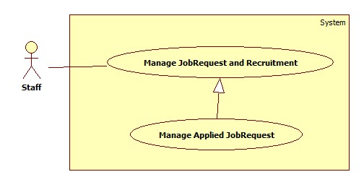

|  |  |  |  |  |
| --- | --- | --- | --- | --- |
| **USE CASE SPECIFICATION** | | | | |
| **Use-case No.** | UC056 | **Use-case Version** | | 1.0 |
| **Use-case Name** | Manage applied jobrequest | | | |
| **Author** | CongNT | | | |
| **Date** | 21/09/2014 | **Priority** | High | |
| **Actor:** Staff  **Summary:** This use case allow staff view all applied jobrequests  **Goal:** Staff can view all applied jobrequests  **Trigger:** User click “Quản lý” link, then click “Xác nhận hoàn tất công việc” link  **Pre-conditions:**   * Page is loaded successfully * User login as staff successful   **Post conditions:**   * Success: Login successfully, the recruitments will be allowed to public on website * Failure:   **Main Success Scenario:**   |  |  | | --- | --- | | Actor Action | System Response | | 1. Login as a staff 2. Click “Hoàn tất yêu cầu” link | 1. System redirect to list of job request 2. System redirect to list of applied jobrequest |   **Alternative Scenario:**   |  |  | | --- | --- | | Actor Action | System Response | | 1. Click on the “Đăng xuất” button. | 1. Clear session and back to home page |   **Exceptions:**   |  |  | | --- | --- | | Actor Action | System Response | | 1. System fail to load data | 1. Show message “Hệ thống đang bảo trì” |   **Relationships:** N/A  **Business Rules:** User login as a staff. The website load all applied jobrequests. | | | | |

###### **<Staff> Approve JobRequest**

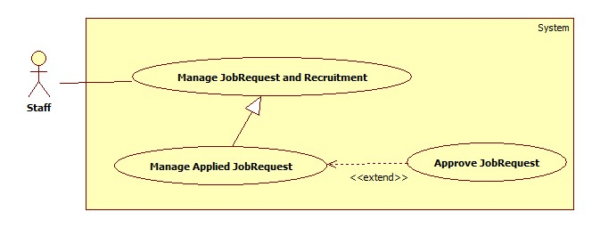

|  |  |  |  |  |
| --- | --- | --- | --- | --- |
| **USE CASE SPECIFICATION** | | | | |
| **Use-case No.** | UC059 | **Use-case Version** | | 1.0 |
| **Use-case Name** | Approve JobRequest | | | |
| **Author** | CongNT | | | |
| **Date** | 21/09/2014 | **Priority** | High | |
| **Actor:** Staff  **Summary:** This use case allow staff to active job request to public it on website  **Goal:** Staff can allow job request to public on website  **Trigger:** User choose a jobrequest then click “Kích hoạt” button  **Pre-conditions:**   * Page is loaded successfully * User login as staff successful   **Post conditions:**   * Success: Login successfully, the job request will be allowed to public on website * Failure:   **Main Success Scenario:**   |  |  | | --- | --- | | Actor Action | System Response | | 1. Login as a staff 2. Click “Kích hoạt yêu cầu tìm người” link 3. Choose a recruitment, click “Kích hoạt” button 4. Click “Chấp nhận” button. | 1. System redirect to list of job request 2. System redirect to list of recruitments 3. System show a “Xác nhận kích hoạt” pop up. 4. Change IsActive(false) to IsActive(true) and save change to database |   **Alternative Scenario:**   |  |  | | --- | --- | | Actor Action | System Response | | 1. Click on the “Đăng xuất” button. | 1. Clear session and back to home page |   **Exceptions:**   |  |  | | --- | --- | | Actor Action | System Response | | 1. System fail to load data | 1. Show message “Hệ thống đang bảo trì” |   **Relationships:** N/A  **Business Rules:** Staff | | | | |

##### <Staff> View Staff Statistic

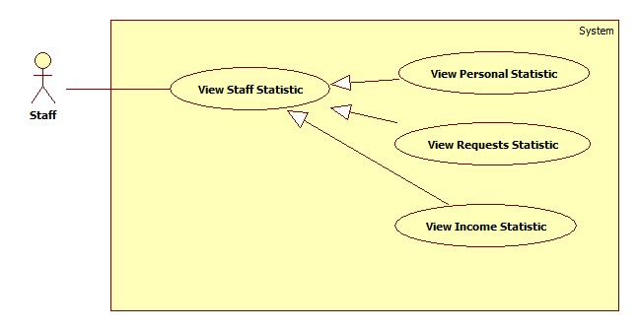

###### **<Staff> View Requests Statistic**

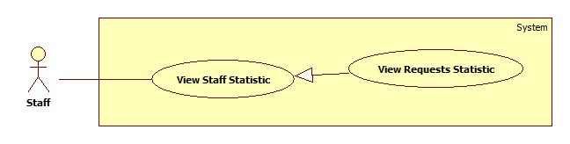

|  |  |  |  |  |
| --- | --- | --- | --- | --- |
| **USE CASE SPECIFICATION** | | | | |
| **Use-case No.** | UC046 | **Use-case Version** | | 1.0 |
| **Use-case Name** | View Requests Statistic | | | |
| **Author** | CongNT | | | |
| **Date** | 21/09/2014 | **Priority** | High | |
| **Actor:** Staff, Webmaster  **Summary:** This use case allow staff see requests statistic  **Goal:** Staff can see requests statistic  **Trigger:** Click on “Các yêu cầu” link  **Pre-conditions:**   * Page is loaded successfully * User login as staff successful   **Post conditions:**   * Success: Login successfully, the statistic will be shown * Failure:   **Main Success Scenario:**   |  |  | | --- | --- | | Actor Action | System Response | | 1. Login as a staff 2. Click name link 3. Click “Thống kê” link 4. Click “Các yêu cầu” link | 1. System redirect home page 2. System redirect personal profile page 3. System redirect personal statistic page and show personal statistic. 4. System redirect personal statistic page and show personal statistic. |   **Alternative Scenario:**   |  |  | | --- | --- | | Actor Action | System Response | | 1. Click on the “Đăng xuất” button. | 1. Clear session and back to home page |   **Exceptions:**   |  |  | | --- | --- | | Actor Action | System Response | | 1. System fail to load data | 1. Show message “Hệ thống đang bảo trì” |   **Relationships:** N/A  **Business Rules:** User login as a staff. | | | | |

###### **<Staff> View Income Statistic**

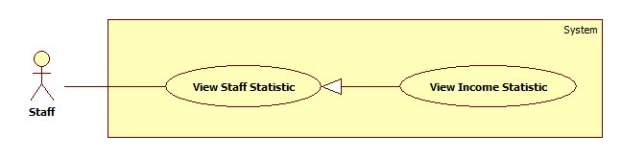

|  |  |  |  |  |
| --- | --- | --- | --- | --- |
| **USE CASE SPECIFICATION** | | | | |
| **Use-case No.** | UC047 | **Use-case Version** | | 1.0 |
| **Use-case Name** | View Income Statistic | | | |
| **Author** | CongNT | | | |
| **Date** | 21/09/2014 | **Priority** | High | |
| **Actor:** Staff, Webmaster  **Summary:** This use case allow staff see income statistic  **Goal:** Staff can see income statistic  **Trigger:** Click on “Doanh thu” link  **Pre-conditions:**   * Page is loaded successfully * User login as staff successful   **Post conditions:**   * Success: Login successfully, the income statistic will be shown * Failure:   **Main Success Scenario:**   |  |  | | --- | --- | | Actor Action | System Response | | 1. Login as a staff 2. Click name link 3. Click “Thống kê” link 4. Click “Doanh thu” link | 1. System redirect home page 2. System redirect personal profile page 3. System redirect personal statistic page and show personal statistic. 4. System redirect income statistic page and show personal statistic. |   **Alternative Scenario:**   |  |  | | --- | --- | | Actor Action | System Response | | 1. Click on the “Đăng xuất” button. | 1. Clear session and back to home page |   **Exceptions:**   |  |  | | --- | --- | | Actor Action | System Response | | 1. System fail to load data | 1. Show message “Hệ thống đang bảo trì” |   **Relationships:** N/A  **Business Rules:** User login as a staff | | | | |

##### <Authenticated user> View Profile

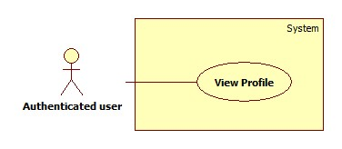

|  |  |  |  |  |
| --- | --- | --- | --- | --- |
| **USE CASE SPECIFICATION** | | | | |
| **Use-case No.** | UC042 | **Use-case Version** | | 1.0 |
| **Use-case Name** | View Profile | | | |
| **Author** | CongNT | | | |
| **Date** | 21/09/2014 | **Priority** | High | |
| **Actor:** Staff, Customer, Maid Mediator, Webmaster  **Summary:** This use case allow user to see his/her profile  **Goal:** User can see his/her profile  **Trigger:** Click on title jobrequest link  **Pre-conditions:**   * Page is loaded successfully * User login as to website successful   **Post conditions:**   * Success: Login successfully, user can see his/her profile * Failure:   **Main Success Scenario:**   |  |  | | --- | --- | | Actor Action | System Response | | 1. Login to website 2. Click name link | 1. System redirect home page 2. System redirect personal profile page |   **Alternative Scenario:**   |  |  | | --- | --- | | Actor Action | System Response | | 1. Click on the “Đăng xuất” button. | 1. Clear session and back to home page |   **Exceptions:**   |  |  | | --- | --- | | Actor Action | System Response | |  |  |   **Relationships:** N/A  **Business Rules:**   * If login as a staff, then click name link,website will redirect to staff’s profile page. Staff could see profile of all members. * If login as a maid mediator, then click name link,website will redirect to maid mediator’s profile page. * If login as a customer, then click name link,website will redirect to customer’s profile page. * If login as a webmaster, then click name link,website will redirect to config page. | | | | |

##### <Authenticated user> Log out

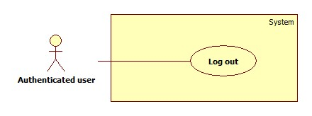

|  |  |  |  |  |
| --- | --- | --- | --- | --- |
| **USE CASE SPECIFICATION** | | | | |
| **Use-case No.** | UC012 | **Use-case Version** | | 1.0 |
| **Use-case Name** | Log out | | | |
| **Author** | CongNT | | | |
| **Date** | 21/09/2014 | **Priority** | High | |
| **Actor:** Staff, Customer, Maid Mediator, Webmaster, Guest  **Summary:** This use case allow to log out website  **Goal:** User can log out website  **Trigger:** Click on log out button  **Pre-conditions:**   * Page is loaded successfully * User login to website successful   **Post conditions:**   * Success: Login successfully * Failure:   **Main Success Scenario:**   |  |  | | --- | --- | | Actor Action | System Response | | 1. Login to website 2. Click log out | 1. System redirect home page 2. System redirect home page and clear session. |   **Alternative Scenario:**   |  |  | | --- | --- | | Actor Action | System Response | |  |  |   **Exceptions:**   |  |  | | --- | --- | | Actor Action | System Response | |  |  |   **Relationships:** N/A  **Business Rules:** User must log in to website. | | | | |

##### <Authenticated user> View JobRequest

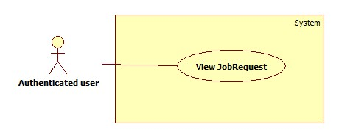

|  |  |  |  |  |
| --- | --- | --- | --- | --- |
| **USE CASE SPECIFICATION** | | | | |
| **Use-case No.** | UC009 | **Use-case Version** | | 1.0 |
| **Use-case Name** | View jobrequest | | | |
| **Author** | CongNT | | | |
| **Date** | 21/09/2014 | **Priority** | High | |
| **Actor:** Staff, Customer, Maid Mediator, Webmaster  **Summary:** This use case allow to view jobrequest  **Goal:** User can view jobrequest detail  **Trigger:** Click on title jobrequest link  **Pre-conditions:**   * Page is loaded successfully * User login to website successful   **Post conditions:**   * Success: Login successfully * Failure:   **Main Success Scenario:**   |  |  | | --- | --- | | Actor Action | System Response | | 1. Login to website 2. Click title jobrequest link | 1. System redirect home page 2. System redirect jobrequest detail page. |   **Alternative Scenario:**   |  |  | | --- | --- | | Actor Action | System Response | |  |  |   **Exceptions:**   |  |  | | --- | --- | | Actor Action | System Response | |  |  |   **Relationships:** N/A  **Business Rules:**   * If user log in as customer, user must click “Người tìm việc” tab, then click title jobrequest link. * If user is a guest or login as a staff, maid mediator, webmaster, user click title jobrequest link. | | | | |

##### <Authenticated user> View Recruitment

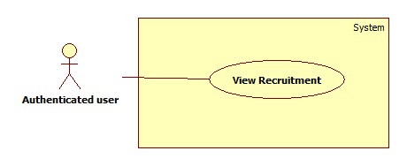

|  |  |  |  |  |
| --- | --- | --- | --- | --- |
| **USE CASE SPECIFICATION** | | | | |
| **Use-case No.** | UC010 | **Use-case Version** | | 1.0 |
| **Use-case Name** | View recruitment | | | |
| **Author** | CongNT | | | |
| **Date** | 21/09/2014 | **Priority** | High | |
| **Actor:** Staff, Customer, Maid Mediator, Webmaster, Guest  **Summary:** This use case allow to view jobrequest  **Goal:** User can view recruitment detail  **Trigger:** Click on title recruitment link  **Pre-conditions:**   * Page is loaded successfully * User login to website successful   **Post conditions:**   * Success: Login successfully * Failure:   **Main Success Scenario:**   |  |  | | --- | --- | | Actor Action | System Response | | 1. Login to website 2. Click “Việc tìm người” tab 3. Click title recruitment link | 1. System redirect home page 2. System redirect recruitment page. 3. System redirect recruitment detail page. |   **Alternative Scenario:**   |  |  | | --- | --- | | Actor Action | System Response | |  |  |   **Exceptions:**   |  |  | | --- | --- | | Actor Action | System Response | |  |  |   **Relationships:** N/A  **Business Rules:**   * If user log in as a staff, maid mediator, webmaster, user must click “Việc tìm người” tab, then click title recruitment link. * If user is a guest or login as a customer user click title recruitment link. | | | | |

##### <Authenticated user> View Notifications

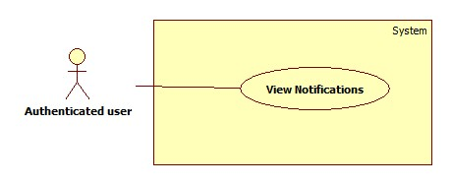

|  |  |  |  |  |
| --- | --- | --- | --- | --- |
| **USE CASE SPECIFICATION** | | | | |
| **Use-case No.** | UC013 | **Use-case Version** | | 1.0 |
| **Use-case Name** | View notifications | | | |
| **Author** | CongNT | | | |
| **Date** | 21/09/2014 | **Priority** | High | |
| **Actor:** Staff, Customer, Maid Mediator, Webmaster  **Summary:** This use case allow to view notifications  **Goal:** User can view notifications  **Trigger:** Click on title icon notifications link  **Pre-conditions:**   * Page is loaded successfully * User login to website successful   **Post conditions:**   * Success: Login successfully * Failure:   **Main Success Scenario:**   |  |  | | --- | --- | | Actor Action | System Response | | 1. Login to website 2. Click icon notifications link | 1. System redirect home page 2. System redirect notifications page. |   **Alternative Scenario:**   |  |  | | --- | --- | | Actor Action | System Response | |  |  |   **Exceptions:**   |  |  | | --- | --- | | Actor Action | System Response | |  |  |   **Relationships:** N/A  **Business Rules:**   * If user log in as a staff, notifications show that jobrequests or recruitments is not active or is not paid, so staff have to active those jobrequests or recruitments. * If user log in as a customer or maid mediator, notifications show that your recruitmenst or jobrequests are applied. | | | | |

### Software System Attributes

#### Reliability

* There is no requirement for system maintenance task from the user.
* Mean Time Between Failures (MTBF): more than 6 months.
* Accuracy: 100%.
* Maximum Bugs and Defect Rate: 0.3 bugs per thousand lines of code (0.3bugs/KLOC).
* Critical bugs:
* Loss of data: not any

#### Availability

* The server shall be working 24 hours per day and 7 days per week.

#### Security

* *All sensitive* information (password, etc.) must be hashed when storing in database and during transmission over networks using MD5 hash.
* Validate input data in SQL query before execute to avoid SQL Injection, XSS
* The role of user and member is clearly.

#### Maintainability

* All code shall fully document. All program files shall include comments concerning authorship and date of last change.
* The code shall be modular to permit future modifications.

#### Portability

* The software will design as cross-platform software.

#### Performance

* Large tables and indexes must be partitioned data into smaller, more manageable sections by using partition in SQL Server 2008 R2

## Entity Relationship Diagram or Data Structures

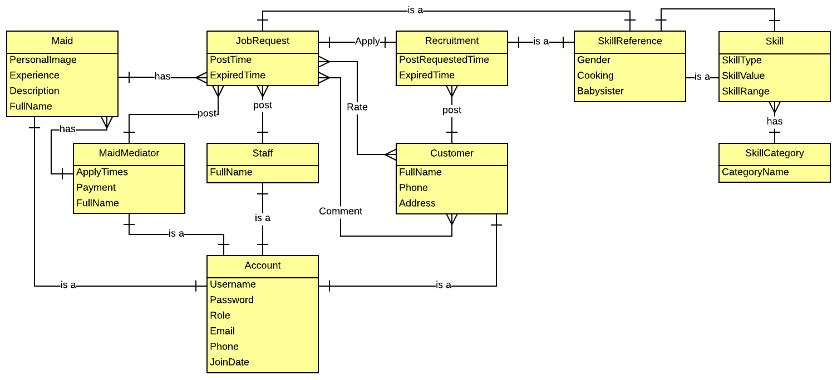

## Other material (if any)

N/A